MariaDB Setup Debian 11

Now that you have Apache setup on your Debian VM, you will set up a database management (DBMS) called MariaDB.

The easiest way to set this up is by using scripts. Download all the script files (.sh) and .conf file from the Database module. If you are running Debian 11 you will be using the mariainstall script for Debian 11. This script has to be renamed before it can be used. Once you have downloaded it, rename the script by entering the following command (from the directory that you downloaded the files to):

ren mariadbinstall-debian11.sh.txt mariadbinstall-debian11.sh

We are going to import all the scripts in the bin directory of debian and in order to copy anything to the bin directory we need to give full permissions to the user.

Switch user to root by using su command and then enter the password for the root user. Change the permissions of the bin directory by using the following command:

chmod 777 /bin

Using WinSCP on your host machine, connect to the Debian by using SSH. Copy the mariadbinstall.sh file to the bin directory in debian.

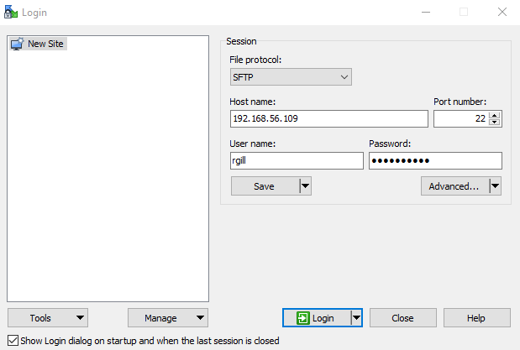

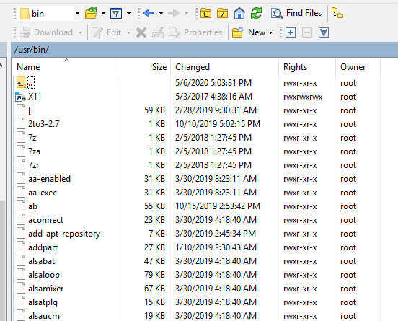

To run the script in debian, assign full permissions first by using the following command:

chmod 777 /bin/mariadbinstall-debian11.sh

Then,

/bin/mariadbinstall-debian11.sh

Using above script, php and MariaDB is installed now. To setup the password for MariaDB, enter the command:

mysql_secure_installation

This will take you through a series of prompts where you can make some changes to your MariaDB installation’s security options. Firstly, it prompts you to enter current password for root (enter for none), hit enter. The next prompt asks you whether you’d like to set up a database root password. Type Y and then press ENTER and specify the root password as “Password01”. From there, you can press N and then ENTER for all the subsequent questions except the reload privilege tables option. Press Y for reload privilege tables.

When installed from the default repositories, MariaDB should start running automatically. To test this, check its status.

systemctl status mariadb

You’ll receive output showing MariaDB actively running. To exit from command enter ctrl+z.

Now we are going to create a user named admin to access mysql using phpMyAdmin.

Enter command: mysql –u root –p

Now it’s going to ask you for a password, enter Password01. Inside mysql, enter the following commands:

CREATE USER 'admin'@'%' IDENTIFIED BY 'Password01';

GRANT ALL PRIVILEGES ON *.* TO 'admin'@'%' WITH GRANT OPTION;

EXIT;

You will now need to restart the MariaDB so these changes can be made live. The easiest way to do this is:

systemctl restart mariadb

phpMyAdmin Setup

Next, you will also set up an interface into MariaDB using Apache and PHP, called PHPMyAdmin.

http://www.phpmyadmin.net/home_page/index.php

To install phpMyAdmin, we will use WinSCP to copy the phpadmininstall.sh file to the bin directory in debian.

Assign full permissions to the phpadmininstall.sh by using the following command,

chmod 777 /bin/phpadmininstall.sh

Then run the script using

/bin/phpadmininstall.sh

Configure Apache web server

Assign full permissions to the conf-enabled directory by using the following command,

chmod 777 /etc/apache2/conf-enabled

Copy the phpmyadmin.conf file to the conf-enabled directory in apache2 using winSCP.

You will now need to restart the web server so these changes can be made live. The easiest way to do this is:

systemctl restart apache2

To test this, you need only go to your Windows VM and connect to the IP address of your Debian VM as follows (assuming the IP address of your Debian VM is 192.168.56.101)

<http://192.168.56.101/phpmyadmin>

You will need to log in. Please login as admin with a password (Password01).

You may see along the left side that you have existing databases to check out. You may click on them to see what they hold.